2026–2028 Iowa West District Mission Grant No. 3
Sharing the Light of Christ — Supporting New Missionaries
Mission Central | $16,000

But you will receive power when the Holy Spirit has come upon you, and you will be my witnesses in Jerusalem and in all Judea and Samaria, and to the end of the earth” (Acts 2:8).

“People are eager to hear about Jesus. The challenge is great, but God has sent pastors, vicars, teachers, and missionaries to reach out to those in need,” states Gary Thies, Mission Development Counselor for the LCMS located at Mission Central. This grant will help provide initial support for three vicars who will serve for two years in the respective countries of the Dominican Republic, Japan, and Germany. They will be preaching the Word of God, assisting with worship, and reaching out with Christ’s love to the people around them. The vicar serving in Germany will also be working with the Lutheran Church in France and ministry to Iranians living in Germany. Two pastors working in the Latin America and Caribbean region, one in Panama and one in Puerto Rico, will work to plant churches in these countries. They will also train new leaders as they mentor those wanting to become pastors or church leaders. Based in Romania, a husband-and-wife team will be teaching English as a second language, which provides the opportunity for the proclamation of the Gospel. Another missionary that will be supported is based in Belize and will serve as the volunteer coordinator, provide support for short-term volunteers serving in the country, and serve as a resource for any LCMS team working in Belize. The grant of $16,000 will help defray the costs of i.e. visas and government documentation, flights to and from the mission location, language training, housing, and salary compensation.

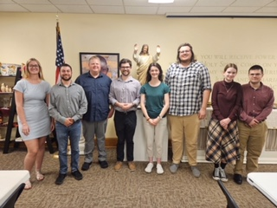

Dear Father in heaven, we give thanks for the men and women who serve as missionaries around the world. Bless their work as they teach others about Jesus and the love He has them. Be with them as they raise funds to support their ministry in the field. Help us all to give of our bounty and pray for them as they spread the love of Christ. In His name we pray. Amen.

